Products Grid with Angular Materia
Objective:
- Adding Product Grid component
- Add Product Card Cart component
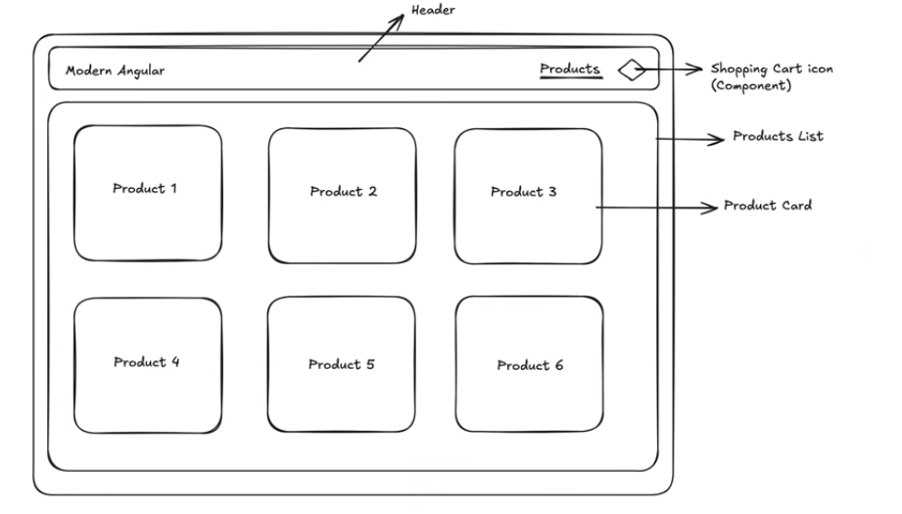
- Continue from previous lab. Make sure that the Terminal Server is there and run the web project.
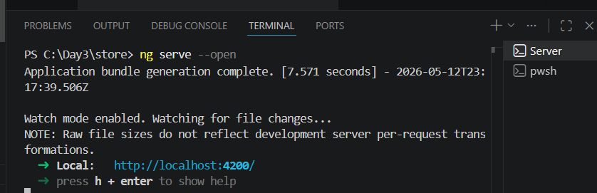
- Should have another Terminal window ready for other task. In this Terminal window, run the command ng g c products/products-grid
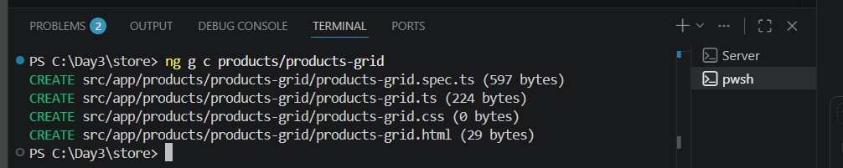

- Copy the selector from producs\produtcs-grid.ts
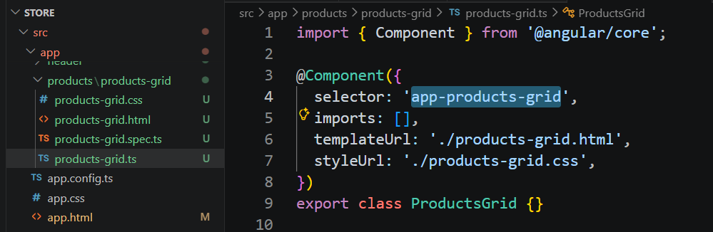
- Paste this selector to app.html inside a new <main> tag.
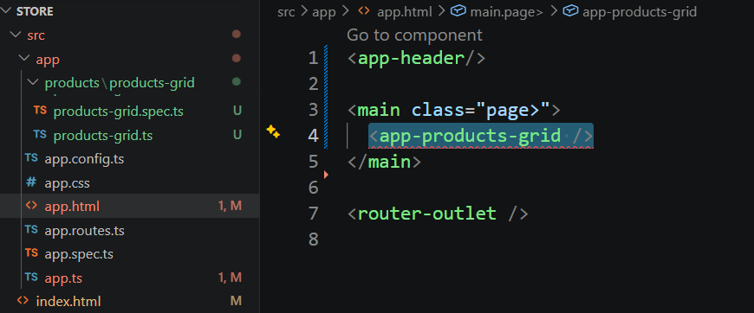
Note: Ignore the error. We not yet import this component in app.ts
- In the App.ts, add the grid component
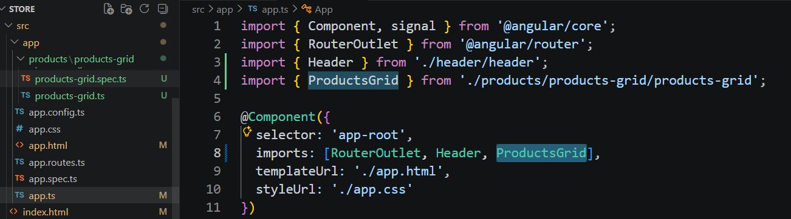
- Add CSS script to App.css
.page{
padding: 16px;
max-width: 1200px;
margin: 0 auto;
}

- Save All, now the web page should look like this
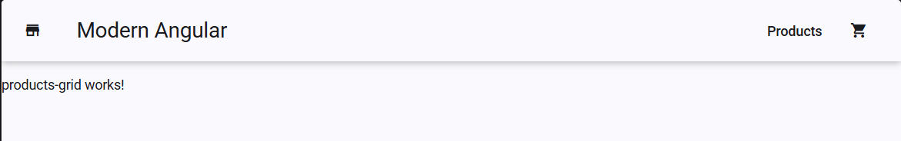
- Next, we will create product-cart component from Terminal by running command
ng g c products/product-card
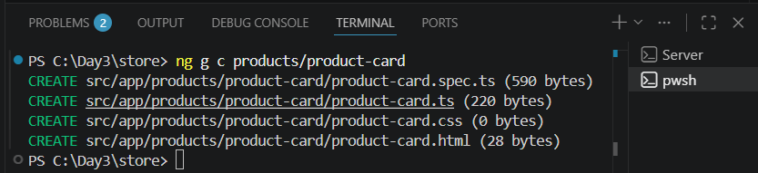
- This Product-Card component needs a MatCardModule component. In the TS file, lets add it in
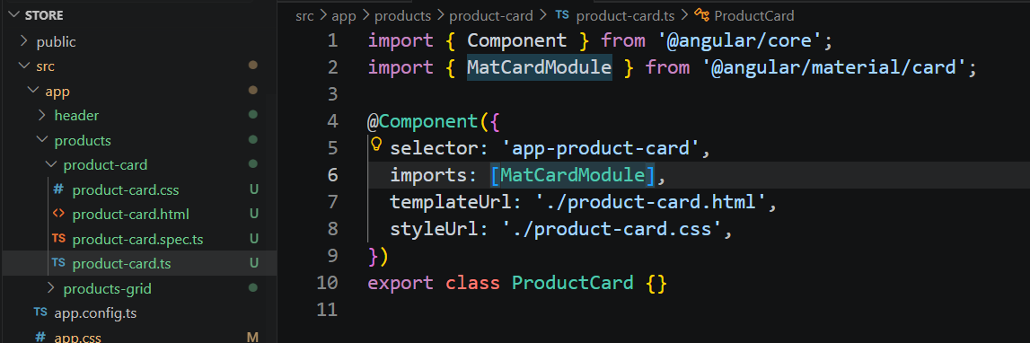
In case you forget about the material, can go back to the Angular Material Page.
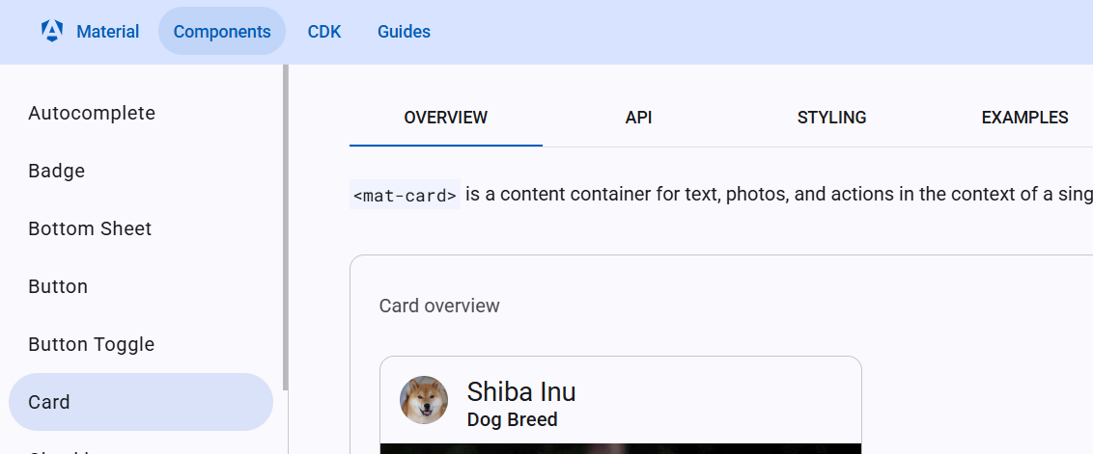

- Add CSS script to Product-Card component
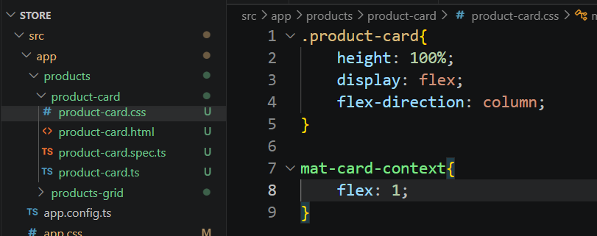
- Add this Cart component to Products/ products-grid.html
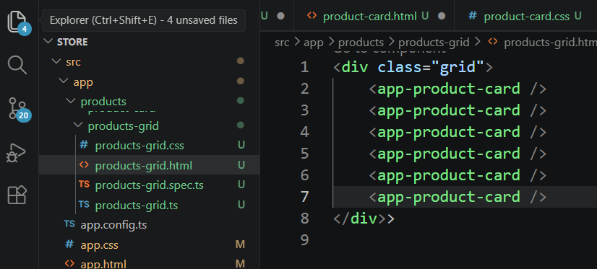
- In the Products/ products-grid.css
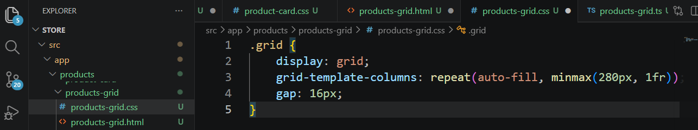

- Save All. Now the web page should look like this
